**Cerebral Palsy Sport RaceRunner taster session at Keepmoat Athletics Stadium, Doncaster.**

On Tuesday 26th August 2014 Cerebral Palsy Sport will be holding a RaceRunner taster session at Keepmoat Stadium, Stadium Way, Doncaster DN4 5JW from 10.30am until 12.30pm.

The day is aimed at children and Adults with cerebral palsy or a physical disability between the ages of 5 and above to have a go at RaceRunning.

If this is not appropriate for you, please would you pass on the information to anyone in your area who might be interested in attending the event.

Please do not hesitate to get in touch if you require further information.

Best wishes,



Katy Johnson

National Junior Development Officer 

[katy.johnson@cpsport.org](mailto:katy.johnson@cpsport.org)

0115 925 6442

**Introducing RaceRunner**

RaceRunner is a new sport in England being piloted by Cerebral Palsy (CP) Sport. It is for children, young people and adults who cannot functionally run and rely on sports aids for mobility and balance.

RaceRunner is a three wheeled frame where the athlete is supported by a saddle and body plate. The athlete propels against the frame using their feet, and steers using the mobility within their hands and/or arms. People with physical disabilities in other countries already participate in Race Runner – including Scotland.

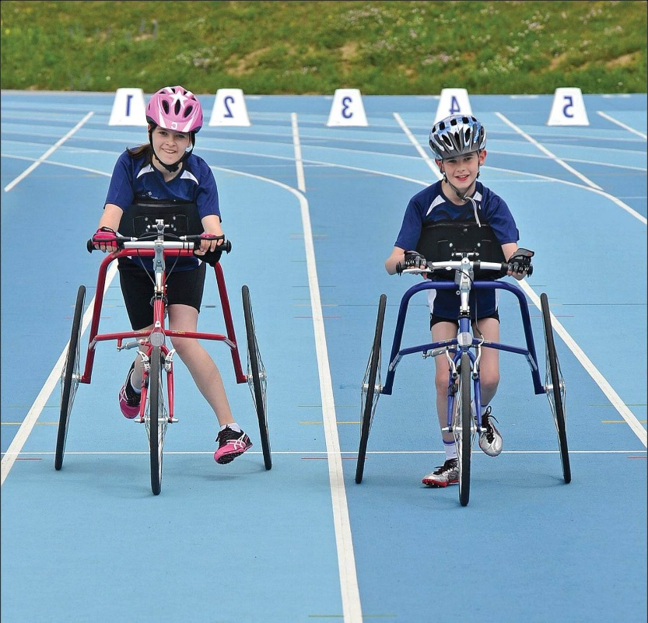

RaceRunner was invented in Denmark in the 1980s, the sport received international recognition in the mid 1990’s.

RaceRunner is known to have amazing benefits for the athlete:

* Freedom of movement and independence that athletes may not have experienced before
* A rehabilitation/physiotherapy aid – including walking gait
* A training aid for other physical activities, improving the cardio vascular system and muscle strengthening

Reference: Presentation to delegates at the European Paralympic Committee Youth Games in Brno, Czech Republic in 2012. Given by Craig Carscadden, CPISRA Development Officer and International Race Runner classifier.